Ideation phase
Brainstorm& Idea Prioritization Template

Date | 1November2025
Team ID | NM2025TMID02619
Project Name | Calculating family Expenses using service now
Maximum Marks | 4 mark

Calculating Family Expenses using ServiceNow Template:
This guided project demonstrates how to design and automate a family expense management system using ServiceNow. The goal is to provide an easy way for users to record, categorize, and analyze monthly family expenses directly within the platform.
The system allows users to add expenses under specific categories such as Food, Rent, Education, Bills, Transport, and Savings. Each entry includes fields for amount, date, payer, and description. Business rules and workflows ensure that the data entered is accurate, and calculations are automatically performed to display the total monthly spending, remaining budget, and expense trends.
A dashboard is created using ServiceNow’s reporting tools to visualize spending patterns and highlight areas where costs can be reduced. Notifications or reminders can also be configured to alert users when expenses cross the set budget limit.
The workflow includes validation rules to ensure:
- Expense entries cannot be saved with missing mandatory fields.
- Monthly reports are generated automatically.
- Users can view and download reports for financial tracking
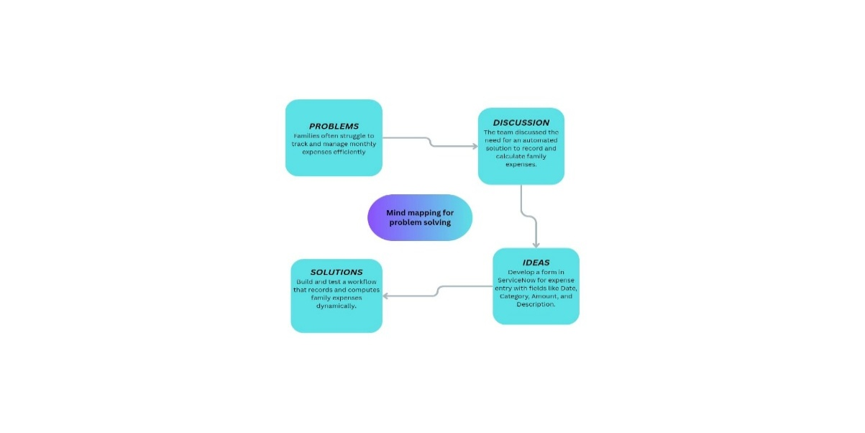
Step-1: Team Gathering, Collaboration and Select the Problem Statement
Reference : https://www.canva.com/design/DAG3hxt8R-k/0wHucKhTuMwjSf3Vs6GxZg/edit?utm_content=DAG3hxt8R-k&utm_campaign=designshare&utm_medium=link2
Step-2: Family Expenses Idea Listing and Grouping
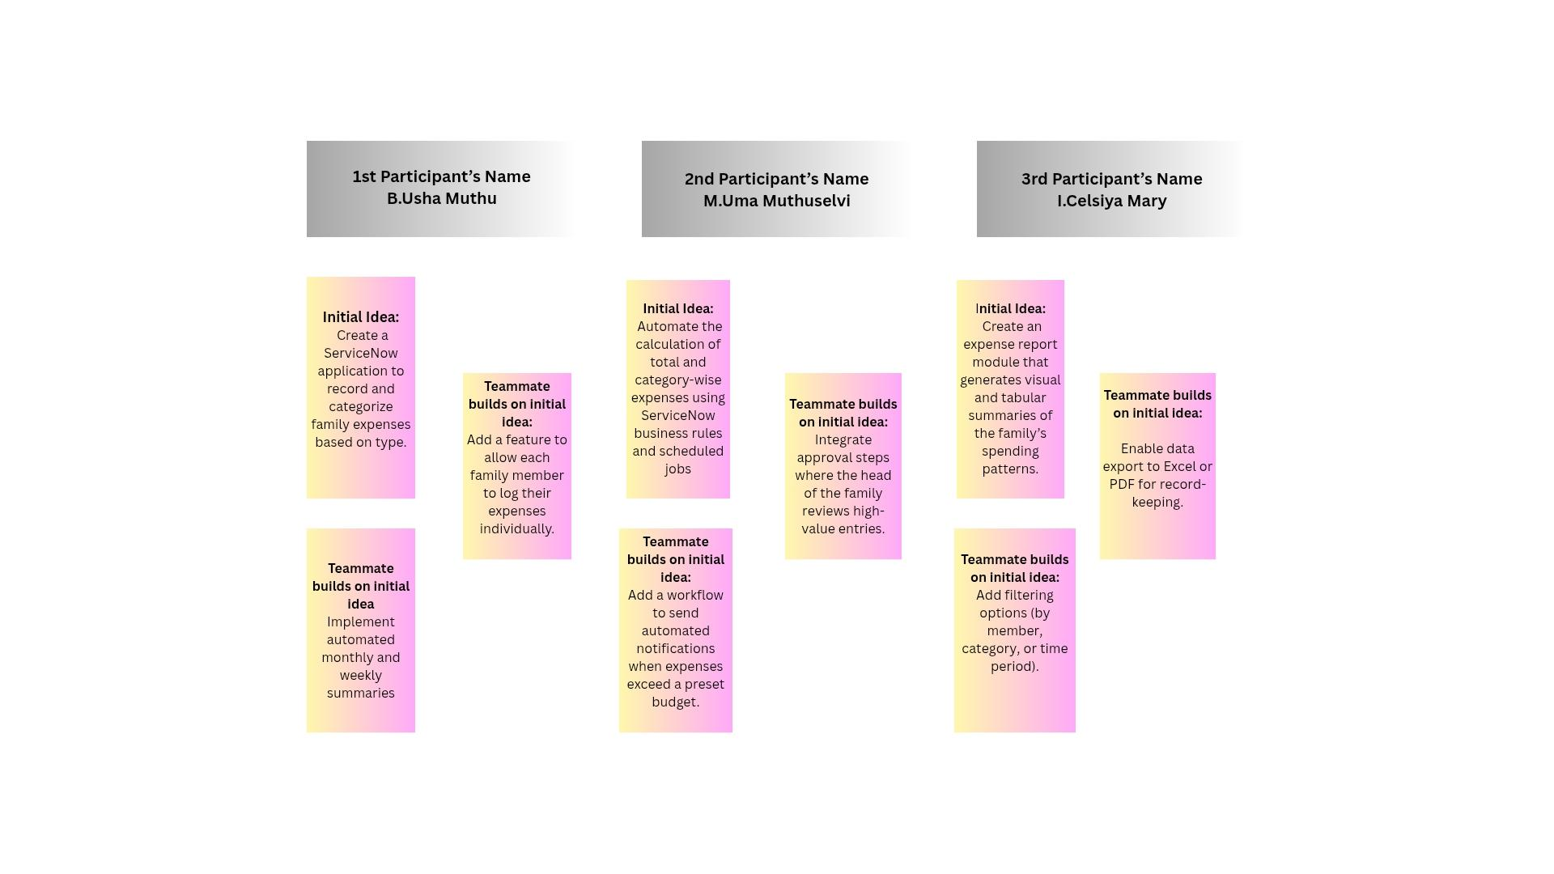
Reference:https://www.canva.com/design/DAG3iFxrOi8/1DYTkEG_AylRFvKCemDgjw/edit?utm_content=DAG3iFxrOi8&utm_campaign=designshare&utm_medium=link2&utm_source=sharebutton

Brainstorm:
Team members shared ideas freely to explore effective ways of managing and calculating family expenses through ServiceNow. Each member contributed different perspectives on automation, visualization, and user interaction, encouraging creativity and collaboration.
IdeaListing:
All proposed ideas were documented during the session to ensure that no potential feature or enhancement was missed. Suggestions included expense categorization, report automation, budget alerts, and dashboards for tracking spending patterns.
Grouping:
Similar and complementary ideas were grouped together to identify key functionalities — such as expense entry, automation, reporting, and notifications. This helped the team focus on core areas while streamlining overlapping concepts.
Action Planning:
The finalized ideas were converted into specific action steps with assigned roles and deadlines. Tasks such as form design, workflow creation, automation rules, and dashboard setup were distributed among team members to ensure smooth execution and timely delivery of the Family Expense Calculator on ServiceNow.
Step-3: Idea Prioritization
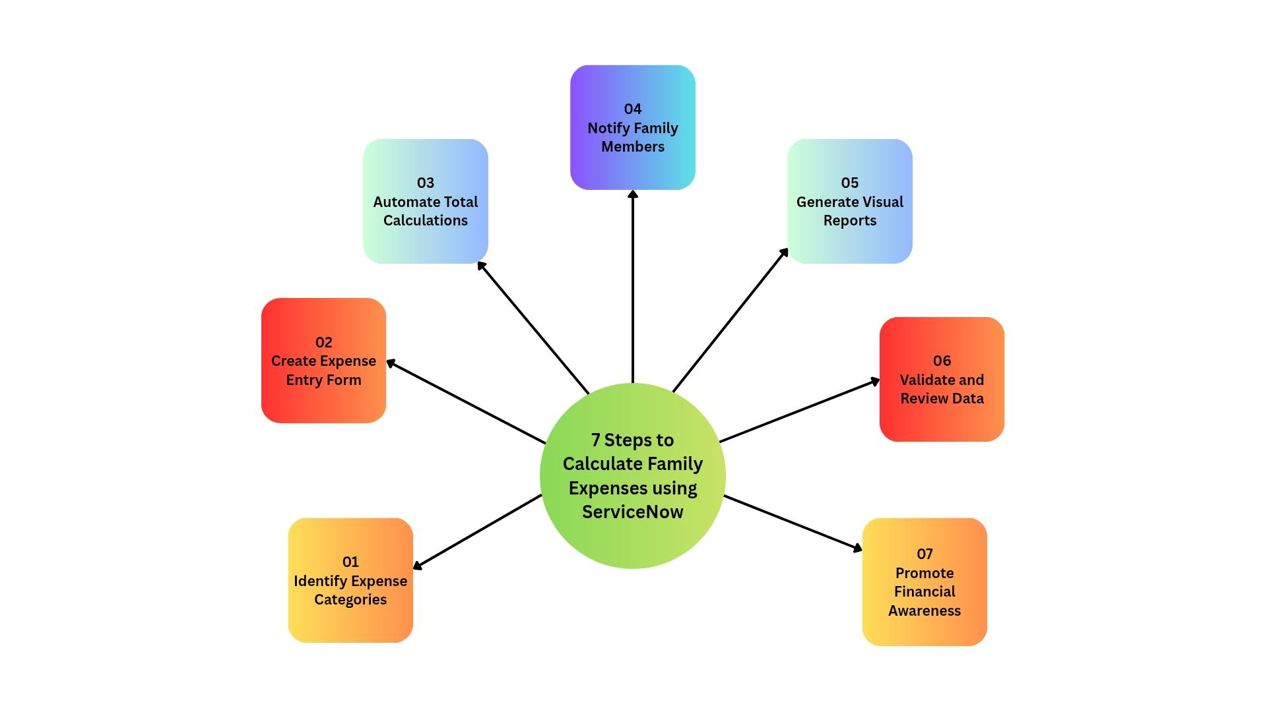
Reference:https://www.canva.com/design/DAG3iW1dfmk/hZdC8x1nJsHkj6PRB0Nu6Q/edit?utm_content=DAG3iW1dfmk&utm_campaign=designshare&utm_medium=link2&utm_source=sharebutton

Idea prioritization
These seven prioritized steps ensure a structured, automated, and insightful approach to managing and analyzing family expenses within ServiceNow.
The prioritization helps streamline data collection, automate calculations, and promote informed decision-making through clear visual insights.

